Potential & Kinetic Energy

DIRECTIONS: Read each scenario below carefully. Determine if the system described is in a Potential State of Energy or in a Kinetic State of Energy.
System | Potential or Kinetic State of Energy
A car traveling @ 100 mph along a flat road
A rubber band that has been stretched
A bowling ball rolling down a lane
A piano lifted by a crane to a second story window
A skateboarder jumping off a ramp
A basketball player dribbling a ball

DIRECTIONS: Look carefully at each picture. Use BAM to describe what work is being done or can be done in the image. Choose a system and describe whether the system is in a Potential state of energy or a Kinetic State of Energy. Then, explain how the Potential Energy can be transformed into Kinetic Energy or vice versa. thinking.
Figure 1Steph Curry preparing to take a shot.
1. _________________________________________________________________
___________________________________________________________________
___________________________________________________________________
___________________________________________________________________
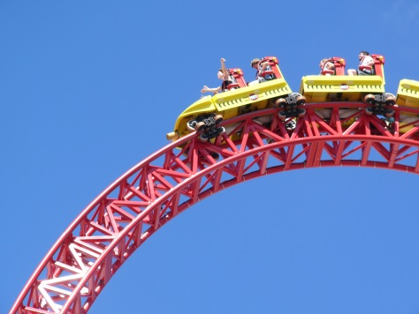
Figure 2Roller Coaster at the top of a steep hill.
2. _________________________________________________________________
___________________________________________________________________
___________________________________________________________________
___________________________________________________________________

Figure 3Bowl of salad
3. _________________________________________________________________
___________________________________________________________________
___________________________________________________________________
___________________________________________________________________

