Kinetic and Potential Energy:
Roller Coaster
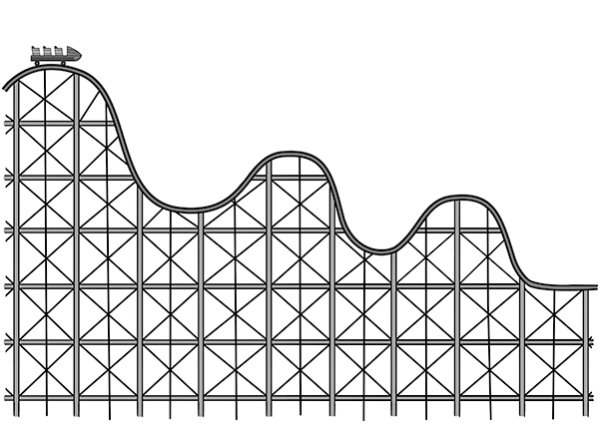
Using the Law Of Conservation Of Energy, explain, in detail, how kinetic energy is transformed into potential energy on a roller coaster and vice versa. Be sure to explain the differences and similarities between kinetic and potential energy in your response.

_____________________________________________________________________________________________________________________________________________________________________________________________________________________________________________________________________________________________________________________________________________________________________________________________________________________________________________________________________________________________________________________________________________________________________________________________________________________________________________________________________________________________________________________________________________________________________________________________________________________________________________________________________________________________________________________________________________________________________________________________________________________________________________________________________________________________________________________________________________________________________________________________________________________________________________________________________________________________________________________________________________________________________________________________________________________________________________________________________________________________________

