Part 1: Practicing Metric Conversions

Use the staircase method. Convert each measurement below to the unit listed.

- 3g=___________________milligrams
- 4421mL=_______________dkL
- 3.66m=________________ cm
- 370 dm=_______________ dkm
- .02 cg=_________________ dg
- 5L = ____________________ hL

Part 2: Calculating Gravitational Potential Energy
Use the formula for calculating Gravitational Potential Energy to solve the problems below. Remember to use the appropriate metric units and show your work.
Reminders:
PE_{grav}=mgh
- m stands for mass which must be measured in kilograms!
- g stands for acceleration due to gravity which is always the same on earth. Write the rate in the space below.
Acceleration due to Gravity on Earth: ___________________
- h stands for height which must be measured in meters!

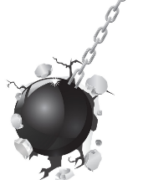
A wrecking ball hanging from a crane has a mass of 450 kg and is 27.4m high. How much Gravitational Potential Energy does the wrecking ball have?

At the grocery store, Veronica bought 4 apples which had a mass of 253.6g. When she got home, she put them in her fruit basket which is 2.13 m above the ground. How much Gravitational Potential Energy do the apples have?

During one of your lab trials, held a ping pong ball at a height of 50cm. The ball had a mass of 26.4g. How much gravitational potential energy did the ball have during this trial?

